Research document

Jumbo Project

Semester 7

The Green Team

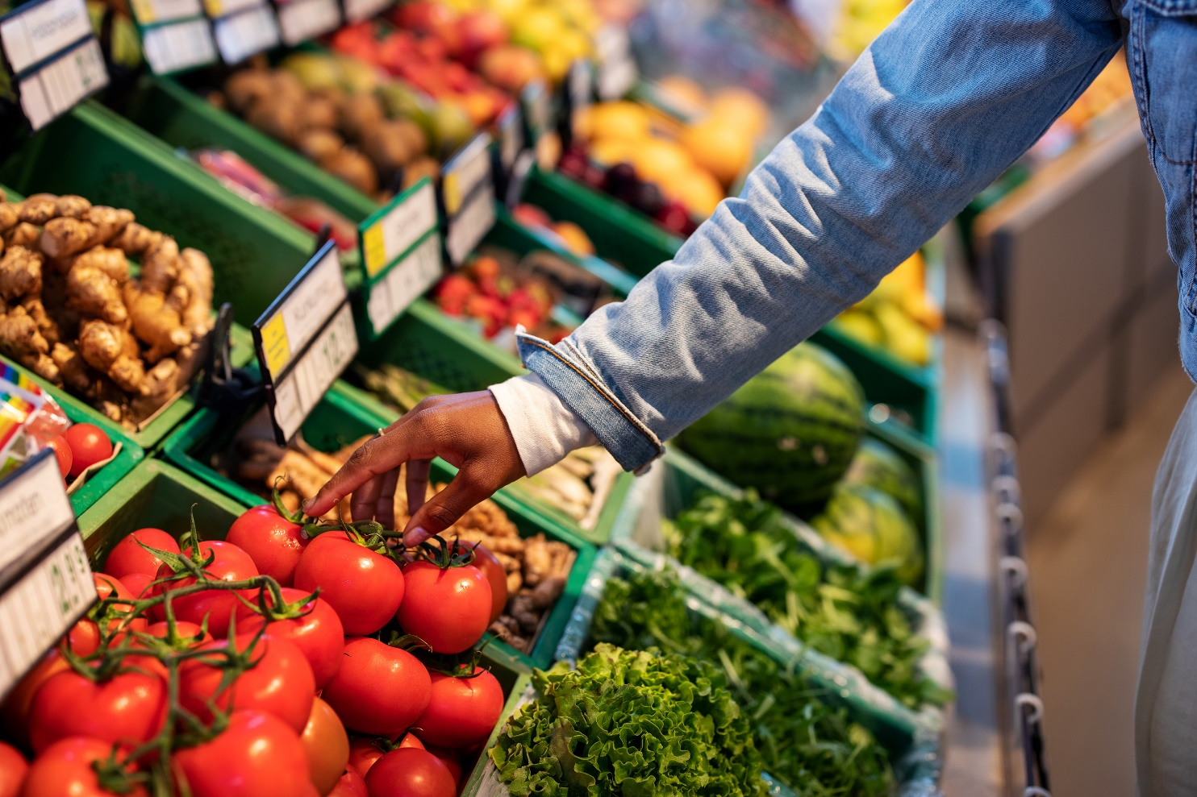

Contents

Sub Questions 3

1. What is conscious consumption? 3

2. What defines Jumbo Supermarkets? 3

3. How does Jumbo compare to its competitors? 3

4. What apps or service does Jumbo currently provide? 4

5. What type of grocery shoppers are there? 7

6. What pain points do grocery shoppers experience in-store? 7

7. Which aspects of grocery shopping could add value to Jumbo and its customers? 8

8. How might we personalize the in-store grocery shopping experience? 10

9. How might we encourage shoppers to make more conscious decisions? 11

10. What mobile app framework or technology best fits the Jumbo project? 12

11. What are existing EU laws and regulations regarding food safety and allergens? 13

Conclusion 14

Bibliography 16

Main Research Question  
The question was derived from the given assignment, discussions with the client and other stakeholders. The main research is the center of all research made in this project.

It gave rise to the sub questions below and encouraged the team to apply various ICT research methods.

# Sub Questions

## What is conscious consumption?

**Goal: Clarification of the main research question**

**Methods: Literature Study (Library)**

**Results:** “Conscious consumerism is when buying practices are driven by a commitment to making purchasing decisions that have positive social, economic, and environmental impact.” Consumers question if the consumption is necessary, then once they decide to buy, they look carefully at who is providing the product and how the product impacts each environment that was touched in its creation and delivery.

**Conclusion:**

Conscious consumerism is gaining momentum as a movement. Eliminating impulse buys and opting for companies and products that create a positive impact, consumers increasingly show a preference for sustainable businesses and products.

**Recommendation:**

Businesses should tap into this new consumer movement if they wish to stay relevant.

## What defines Jumbo Supermarkets?

**Goal: Understanding the core values of Jumbo brand**

**Methods: Literature Study (Library)**

**Results: The customer is at the center of focus for Jumbo. They aim to offer the best quality products for the lowest prices all while making shopping experience enjoyable with the help of “7 zekerheden”.**

**Conclusion:**

Jumbo cares about the customer perception of the brand. They try to ensure the best shopping experience and predict the ever changing consumer interests.

## How does Jumbo compare to its competitors?

**Goal**

Finding out who the competitors from Jumbo are, and how Jumbo compares to them.

**Methods**

* Literature study (Library)
* Competitive analysis (Library)

**Results**

By searching on the internet for relevant sources and looking at Jumbo competitors and their offerings, the schema below was created.

|  |  |  |  |  |  |  |
| --- | --- | --- | --- | --- | --- | --- |
|  |  |  |  |  |  |  |
| No. stores | 685 | 445 | 420 | 985 | 270 | 507 |
| Market Share in % (2021) | 21.8 | 1.2 | 10.7 | 35.9 | 6.5 | 5.2 |
| Revenue | 9.9 billion EUR (2021) | 828.6 million EUR (2020) | $69 million (2021 NL) | 44.6 billion EUR (2021) | 2.61 billion EUR (2019) | 2.5 billion EUR (2018) |
| Selling Channels | Online, Local, Commercial | Online, Local | Local,  Online (non-food items) | Online, Local, Commercial | Online, Local, Commercial | Local |
| Awards | Online supermarket, Cheapest | ? | Fruit and vegetables | Packaging waste fund award | Meat products | Private label Product of the Year |
| Social Media Presence | Instagram,  Facebook, LinkedIn | Facebook (int.), LinkedIn (int.),  Instagram (int.) | Instagram,  Facebook,  LinkedIn | Instagram,  Facebook, LinkedIn | Facebook, LinkedIn | Instagram, Facebook, LinkedIn, Youtube |
| Delivery | YES | YES | NO | YES | YES | NO |

Table 1. schema with important details like market share and awards.

**Conclusion**

The most significant competitor of Jumbo is Albert Heijn. Aside from having a bigger market share, more revenue and more stores, Albert Heijn is also perceived as the “most sustainable” supermarket. On the other hand, Jumbo won awards for having the best online shopping experience and being the cheapest.

**Recommendations**

As sustainability and customer perception is getting more important by the day, it is a smart move for Jumbo to invest in being more sustainable and healthier.

## What apps or service does Jumbo currently provide?

**Goal**

Finding out what apps and services Jumbo provides to find out if something critical is missing.

**Methods**

* Literature study (Library)
* Available product analysis (Library)

**Results**

The following results were generated from looking on the internet and analysing existing Jumbo apps.

**1. Jumbo App (general)**

The main Jumbo app serves as an E-Commerce application. Some of the features are:

* Product catalogue
* Shopping list
* Online ordering with delivery
* Favourite products and recipes
* Find a store or Pick Up Point

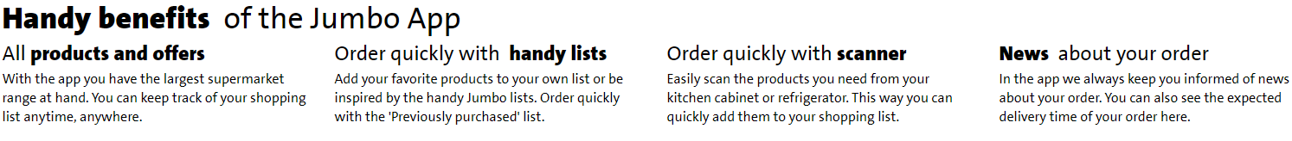

The general Jumbo app is mostly designed for deliveries. Through the app, it is possible to see the shopping list the user made and add it to either a home delivery or a pickup point order.

Aside from this, the Jumbo app can also be used to make a shopping list which can simply be used in-store. Ordered per category, the products will be easier to find than searching manually.

The Jumbo app has a couple of premade lists of groceries, like ‘often forgotten’ or ‘bbq’.

Interestingly, despite not being advertised online, the app has a lot of useful features. A section in the app is called recipes and contains many categories from which the desired recipes can be found. For instance, the first section is dedicated to a weekly changing menu. Categories like vegan, few ingredients or short cooking time exist in order to fulfil exactly what the customer wants to see. It lists the amount of ingredients needed, how long the cooking will   
take and instructions.

Aside from this, the app also lists the bargains in a separate section. From the section, bargains can be viewed per week, season, deliveries only or all. From the general app, complaints can be filed as well. As a final note, from within this app, product codes can be scanned to enable quick paying at the register.

All functions described here are also available on the Jumbo website, with in-store scanning being the obvious omission.

**2. Jumbo Extra's app**

“Download the Extras app and create a digital pass or activate your physical pass. Enjoy all the benefits by always scanning your Extras pass at the checkout.”

With the Jumbo Extras app, the customer can generate points by shopping groceries. These points can be spent on a variety of items and activities. For instance, points that a customer saved can be spent on free groceries, amusement parks, sports and merchandise.

The customer can gather points by scanning their Extras pass in store. As well as scanning, the customer can choose specific items that have a temporarily increased amount of Extras points.

The points saved can be used in physical form on paper or digitally by logging in to the app.

Finally, the app can be used for a couple of preferences. For instance, if the customer only wants to receive the receipts digitally, this can be applied in the setting with this app. This app also contains all the receipts that the customer has received while using the Extras pass.

**3. Jumbo Foodcoach app**

The Jumbo Foodcoach app is like the regular Jumbo app, focused on healthy recipes and recommending alternative products and ingredients to use.

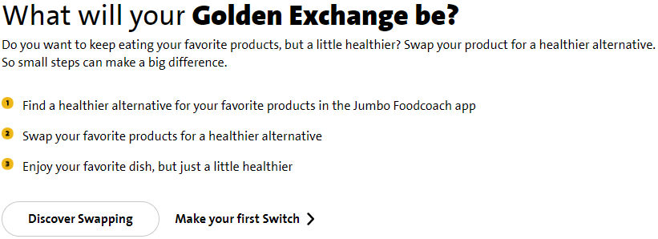

Features:

* Discover healthy recipes: low carb, low calories, vegetarian and sports-based diets.
* Add recipes to favourites in the order you want.
* Add recipes or single ingredients to your grocery list.
* Use your grocery list to order your groceries for pick-up or delivery.
* Get recommendations of recipes based on which sport you do.
* Save up points to use with your purchases.

Pitfalls:

* No English language support, just like the regular Jumbo app.
* Replica of the Jumbo app but with limited functionality. The few extra functionalities offered could be implemented in the actual Jumbo app instead.
* Some reviews say it's too focused on sports-based diets.

**Conclusion**

Jumbo currently provides three separate apps: Jumbo E-Commerce, Extra’s, and Foodcoach. The E-Commerce app is mainly used for ordering groceries online. The extra’s app handles discounts, points, and preferences about receipts. Lastly, the Foodcoach app helps users eating healthier, while still eating what they like.

**Recommendations**

Though the three apps serve different purposes, it could be a good idea to merge those into one general Jumbo app.

## What type of grocery shoppers are there?

**Goal: Identification of customer groups that make up the customer pool at Jumbo**

**Methods:**

**- Literature study (Library)**

**- Observation (Field)**

**- Interviews (Field)**

**Results:**

|  |  |  |  |
| --- | --- | --- | --- |
| **Large seldom shoppers** | **Frequent buyers** | **List makers** | **Cart users** |
| **Scanner users** | **Self-checkout users** | **Conscious shoppers** | **Health fanatics** |
| **Inspiration seekers** | **Group shoppers** | **Loners** | **Lurkers** |
| **Queuers** | **Online shoppers** | **Chatters** | **Bargain hunters** |

**Conclusion:**

Jumbo does not explicitly define its customers as they are focused on shoppers of all ages and incomes. Though, after a bit of online research, live observation of shoppers in-stores and interviewing friends and relatives, several groups of shoppers were identified to help with ideation and prototyping. These groups helped us create personas and improved our brainstorming sessions.

## What pain points do grocery shoppers experience in-store?

**Goal: Determine the difficulties shoppers experience during their shopping trip, based on the different types of shoppers described previously.**

**Methods: Literature study**

**Results**

**For many shoppers, grocery shopping is a chore. It takes a long time, there are long queues and products are difficult to find. For a lot of customers, this is all too familiar. But in order to get a wide range of pain points, the problems will be categorized for a couple of different customer types. This will be based on a literature study and the previously created personas and interviews.**

**For the infrequent shoppers that do large grocery shopping, the experience in-store will be vastly different to the frequent shoppers. Since they don't visit the store often and often prepare the shopping trip thoroughly, they are okay with taking some time in the store and are not as bothered by slow cash registers and queues. This demographic often uses a cart. They are not as likely to use handscanners and self-checkout. The gripes for this target group are largely product related. Unclear labeling and unhelpful employees are among the bigger annoyances. Empty shelves are also not appreciated.**

**In the case of frequent or impulse shoppers, the preparation is not as thorough. A lot of these customers simply go to the store when they're at home, realizing something is missing. Therefore, they often don't make a list and just go get the desired product. Aside from this, the slow progress at the cash-register is a bigger problem for this demographic. That means this group is likely to be more interested in self-checkout. Unhelpful employees are just as bad for this type of shopper as for the bigger shoppers, as are empty shelves.**

**For bargain-hunter shoppers, the most important thing is price. They don't care as much about self-checkout or quick moving queues and are focused on getting the best deal. Therefore, the bargain-hunter's gripes are to do with visibility. They want to be able to see the most discounted item instantly. Misleading and unclear packaging are a big problem for this type of customer. The bargain-hunter will also be very disappointed if they discover that certain products are sold out.**

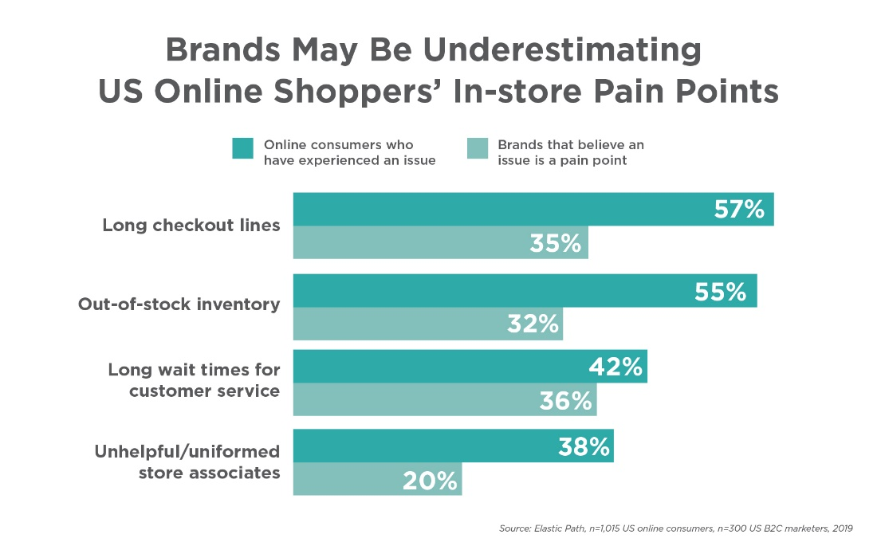

**Conclusion**

**For all customer groups, there seems to be some universal problems. Checkouts can be quite slow. Employees are not always helpful. Some products are not always available. There are, however, some differences among the different types of customers. The impulse shopper is way more bothered by slow checkouts than the other shopper types. On the other hand, although the impulse shopper is also frustrated by this, unclear labeling and illogical product placing is a bigger problem for the large shopper and the bargain hunter.**

**These problems can be quite far apart in terms of solutions. For this reason, in order to make a difference for Jumbo, it is important to establish what solution would be able to solve multiple of these problems.**

## Which aspects of grocery shopping could add value to Jumbo and its customers?

**Goal: Analyze what aspects of grocery shopping could improve the user experience of its customers and how this can be applied, partly based on the results of the previous sub question.**

**Methods: Literature study**

**Results**

**As described earlier, Jumbo values fun during grocery shopping very highly. Although for many people, grocery shopping is a chore, Jumbo believes it can be a fun activity. Based on the outcome of sub question 6, there are many aspects of shopping where Jumbo has opportunities.**

**For problems associated with slow checkout, Jumbo could add a quick payment integration into the Jumbo app. For instance, being able to use a smartphone as a handscanner would go a long way into reducing annoyances. A payment option from the user’s smartphone would be even better, for instance using a Creditcard or iDeal.**

**Hard to find products and unhelpful employees have an obvious but hard to implement solution. In order to maximize efficiency and improve customer satisfaction, Jumbo could add navigation to its software suite. This would dramatically increase the happiness of Jumbo’s customers. There are some challenges to overcome, such as the need to map out all stores in detail. It would also cause customers to wander less in the store, which has a significant impact on revenue according to the client. Still, this function would allow Jumbo to take a sizeable amount of market share, due to its uniqueness and usefulness.**

**Unclear labeling and packaging are difficult problems to solve, especially for groups that have a specific dietary restriction. The problem is also not completely solvable by Jumbo itself, since they don’t control the packaging of most of their products. Therefore, a more out of the box solution is required. A personalized experience could solve a lot of issues. A possible implementation of this is the ability to create profiles. Customers can input their desired ingredients and products to avoid. The preferences could be matched to their database of allergies and other restrictions, which they already have in place. It will allow customers to be more aware of food and ingredients that do not align with their preferences. It is also combinable with the other ideas so far and is therefore very expandable.**

**Aside from these solutions, there are also general things Jumbo could do to increase customer satisfaction during grocery shopping. For instance, gamification could work in Jumbo’s favor, although this has some challenges of its own. A riddles or scavenger hunt game could allow kids to have more fun in the store, whilst keeping them busy so they are less annoying to their parents and other shoppers.**

**Conclusion**

**Amongst the goals Jumbo has set for themselves, making grocery shopping more fun is the most important and discussed aspect, alongside the other Jumbo Assurances. There are several ways to achieve this.**

* **A quick payment option in the app would help the speed of lines at the supermarket.**
* **Navigation through the store with an app would greatly improve efficiency and customer satisfaction.**
* **Personalization would be of great use to customers that have dietary restrictions or, for that matter, have any other preferences.**
* **Some general things to improve fun is the ability to play a Jumbo themed game, especially to keep kids busy.**

Of these options, a quick payment option is likely the easiest to implement. Although simple, it can probably be combined with some of the other ideas. Although the gamification idea, or possibly just a literal game, has a very limited audience and is therefore probably not the most promising idea. In contrast to navigation, which has the widest target audience. The problem is that Jumbo would need to map out all stores, which is not feasible for the foreseeable future according to the client. Considering these facts, personalization is the most promising solution. Although a slightly narrower target group, there are still plenty of people with a dietary restriction or preference of some sort. It would greatly improve the customer experience for this target demographic. It would allow them to check all scanned ingredients and food for possible incompatibilities with their diet.

## How might we personalize the in-store grocery shopping experience?

**Goal: Find ways to make the grocery shopping experience more tailored in stores.**

**Methods:**

* **Literature Study (Library)**
* **Brainstorm (Workshop)**
* **Interviews (Field)**

**Results:**

**Grocery shopping is different from other types of retail, due to the short-lived products needing constant restocking. The risk for grocery stores is that shoppers are not necessarily loyal to a particular store. They might just as well pick up their groceries while out running errands, which may not be the same store they visited a week ago. Thus, the question is how to create and maintain customer loyalty. Loyalty is the outcome of a combination of attributes. It can be influenced by product availability, prices, service level, tidiness of the place, convenience and many other factors. One of the core ways to promote loyalty is to make the shopping experience feel personal.**

**Personalization is the ability to understand and cater to the customer’s needs. Grocery retailers are still largely an in-store experience. Shoppers want to touch and feel many products before they buy them, especially the short-lived items. Therefore, retail owners need more effective ways to personalize the experience before, during, and after a customer visits. Nowadays, it is a combination of data and intelligence to deliver a personal experience. 90 percent of grocery shoppers still shop in-store, though digital remains an important tool in the decision-making process, whether it is used for deliveries, buying online and picking up at the store, using digital means to browse for products or collecting points via the retailer’s app.**

**Using predictive intelligence, retailers can offer consumers the next best offers and recommendations before they realize they need them. Content is vital, but the difference between desired and forced content is about relevance and timeliness. Thus, knowing the customer and their needs is still the core of personalization. This is where digital becomes vital - to track and gather such information. The most common ways to personalize using information gathered via digital means is:**

* **Recommending replacements for out-of-stock-products.**
* **Optimize price and promotions based on previous purchases or dwell time.**
* **Offer alternatives based on shoppers’ preferences or needs.**

**Conclusion:**

**The three core aspects of Personalized shopping experience**

* ***Data*: treating data (usually customer data) as an asset to be properly collected and analyzed**
* ***Intelligence*: synthesize data into insight about consumer buying trends**
* ***Experience*: use the first two to deliver a lovable, personalized experience and improve along**

**The shopping experience can be personalized by:**

* **Using product recommendations**
* **Offering better price and/or promotions**
* **Focusing on special needs**
* **Targeting minorities**

## How might we encourage shoppers to make more conscious decisions?

**Goal: Find ways to help consumers make shopping decisions that are beneficial to them and the environment**

**Methods:**

* **Literature Study (Library)**
* **Brainstorm (Workshop)**
* **Interviews (Field)**

**Results:**

**This research took into consideration the personalization aspect of shopping experience. Specifically focusing on customers with certain needs, such as allergies, intolerances, dietary restrictions or preferences. Thus, we investigated existing possibilities of catering to such customers and talked with them to better understand their struggles. In addition, we had several ideation sessions on how to encourage customers make better decisions.**

**Conclusion:**

Targeting customers with **allergies, intolerances or dietary restrictions would encourage the people to shop at Jumbo, thus improving their loyalty. Using personalization in the form of dangerous ingredient warnings, preferred product recommendations and showing relevant alternatives would help consumers to stay within their needs and values in a convenient way. This could further lead to making more environmentally friendly decisions too.**

## What mobile app framework or technology best fits the Jumbo project?

**Goal:**

**Deciding on a mobile app development framework or technology that can be used to implement the concept. The choice will be made between Flutter and Android Studio as these aligned with personal development goals of the team members.**

**Methods:**

* **Literature study (Library)**
* **Community research (Library)**
* **Multi-criteria decision making (Workshop)**
* **Prototyping (Workshop)**

**Results:**

**First, information about both Flutter and Android was gathered. From these results, a multi-criteria decision-making table was composed.**

|  |  |  |
| --- | --- | --- |
| **Criteria** | **Flutter** | **Android** |
| **Cross platform (iOS, Android)** | **X** |  |
| **Descriptive and useful documentation** | **X** | **X** |
| **Active community** | **X** | **X** |
| **Access to native features** | **X** | **X** |
| **Highly customizable UI** | **X** |  |
| **Easy to compose UI** |  | **X** |
| **Hot-reload** | **X** |  |

**Then, a prototype for both possibilities was made. The goal was to implement a barcode scanner. This gave us an indication of the level of complexity involved.**

**Flutter: Very easy implementation, only a single external package needed**

**Android Studio: Easy implementation as well, also only required a single 3rd party package**

**Conclusion:**

**Based on the defined criteria, Flutter can do pretty much everything that Android Studio can. Moreover, it supports hot-reload, which makes development more pleasant. On top of this, Flutter is a cross-platform solution, which is the most important advantage of using Flutter. Therefore, Flutter fits the Jumbo project the best.**

## What are existing EU laws and regulations regarding food safety and allergens?

**Goal:** Understanding the expectations set by EU (in line with WHO) for food safety

**Methods:**

* Literature study (Library)

**Results:**

Cross-contamination and food allergies are an ever-increasing concern in the EU and throughout the world. The European Green Deal also plays an important part in pushing for waste reduction in food industry. Thus, there are strict regulations for food labeling. If food or beverages are sold in the EU, the seller must provide essential information that is accurate, understandable and indelible, which includes certain allergens. The consumer should be able to make an informed decision on their purchase based on this information. In addition, the Food Safety Culture has been introduced, which enhances food safety by increasing awareness and improving the behavior of employees in food establishments. Moreover, all food vendors must check the quality of the produce to ascertain it is not injurious to health and fit for human consumption.

**Conclusion:**

All businesses handling food must ensure that it meets the following criteria before serving/selling to the consumer:

* BBD leaves enough time for shelving and redistribution until final consumption
* Packaging integrity is undamaged
* Proper storage and handling conditions (i.e., temperature)
* Organoleptic properties
* Assurance of traceability for products of animal origin
* Labels matching the preset criteria.

There are also strict regulations for food labeling. Ingredient list must include any additives and allergen information, they must be listed in descending order of weight. Any allergens (substances or products causing allergies or intolerances used during manufacture or preparation and present in the finished product) present must be highlighted in the list of ingredients, by using a different font, letter size or background color. If there is no ingredients list, any allergens must be included by using ‘contains' followed by the name of the allergen. There are 14 main allergens that are required to be highlighted on labels:

1. Cereals containing gluten, namely: wheat, rye, barley, oats, spelt, kamut or their hybridised strains, and products

2. Crustaceans and products thereof (prawns, crabs and lobsters).

3. Eggs and products thereof.

4. Fish and products thereof (except fish gelatin or Isinglass used as fining agent in beer and wine).

5. Peanuts and products thereof.

6. Soybeans and products thereof (except fully refined soybean oil and fat).

7. Milk and products including lactose (except whey used for making alcoholic distillates and lactitol)

8. Nuts, namely almonds, hazelnuts, walnuts, cashews, pecan nuts, Brazil nuts, pistachio nuts, macadamia and products thereof (except for nuts used for making alcoholic distillates).

9. Celery and products thereof.

10. Mustard and products thereof.

11. Sesame seeds and products thereof.

12. Sulphur dioxide and sulphites at concentrations of more than 10mg/kg or 10 mg/liter.

13. Lupin and products thereof.

14. Mollusks and products thereof.

# Conclusion

Jumbo, the second biggest supermarket in terms of market share and number of stores, deeply cares about brand perception and customer satisfaction. In order to improve the customer experience, Jumbo already deploys the ‘seven assurances’. However, Jumbo Supermarkets is behind in terms of sustainability compared to Albert Heijn, who is generally perceived as the most sustainable supermarket. Jumbo wishes to become more competitive through the combination of sustainability, promotion of conscious consumption and customer satisfaction.

This solution is going to be realized through the creation of an app. Jumbo already has a couple of apps, which don’t have a clear reason for existing separately from each other. Jumbo wants to combine the three apps, and therefore, the new app must be made while keeping in mind that it will likely need be integrated into the main app.

Although Jumbo had a large and hard to define customer base, there are some pain points that Jumbo can take on to solve universal problems or problems that exist for specific customer groups.

* Gamification: With gamification, the brand of Jumbo will increase in value in the eyes of the customers, especially for kids, who will be the main users of the app.
* Navigation: Hard to find products can a thing of the past by using product navigation.
* Quick payment: To reduce queues and improve efficiency, a quick payment option with for instance iDeal, will improve customer satisfaction
* Personalization: To make an impact for a more specific but underrepresented customer group, being able to personalize your shopping experience is very valuable.

Since gamification doesn’t promote conscious consumption and navigation is hard to implement due to the need to map out all the stores, personalization is the best solution for this project. Although, navigation and quick payment can still be integrated into this solution as well, and are a possible expansion opportunity.

To properly utilize personalization, there are three possible use cases, all of which could be implemented into the final version of the app.

* **Recommending replacements for out-of-stock-products.**
* **Optimize price and promotions based on previous purchases or dwell time.**
* **Offer alternatives based on shoppers’ preferences or needs.**

Though all of these options are a possibility, the least represented group are the people with allergies or dietary restrictions. Personalizing for this demographic will give Jumbo a significant unique selling point.

The technological realization will happen with the use of Flutter. Since it has the largest group of supported devices and is very developer friendly, it is the best option. Aside from this, Jumbo already uses flutter to create their apps, and will therefore be able to integrate it more easily.

All in all, in order to improve conscious consumption at Jumbo Supermarkets, the best solution is to create an app that uses personalization to improve the customer experience and recommend alternatives. This allows Jumbo to cater to specific diets, while also being able to make recommendations that promote conscious consumption.

# Bibliography

Aanbiedingen folders. (2021, February 27). *Top 20 Grootste Supermarktketens Van Nederland*. Retrieved from Aanbiedingenfolders: https://www.aanbiedingenfolders.nl/blog/grootste-supermarktketens-nederland-7

Albert Heijn. (2022, Juni 9). *Albert Heijn en Hordijk winnen Afvalfonds Verpakkingen Award*. Retrieved from Nieuws AH: https://nieuws.ah.nl/albert-heijn-en-hordijk-winnen-afvalfonds-verpakkingen-award/

European Commision. (2021, March 3). *Food safety, allergies & food waste – new EU rules*. Retrieved from European Commison: https://ec.europa.eu/info/law/better-regulation/have-your-say/initiatives/12230-Food-safety-allergies-food-waste-new-EU-rules_en

European Union Law. (2011, October 25). *Regulation (EU) No 1169/2011 of the European Parliament on the provision of food information to consumers.* Retrieved from EUR-Lex: https://eur-lex.europa.eu/legal-content/EN/ALL/?uri=CELEX:32011R1169&qid=1668077990109

ExpatINFO Holland. (2022). *Biggest Supermarkets In Holland*. Retrieved from Expat i Holland: https://expatinfoholland.nl/help-guides/shopping-foods/10-largest-supermarket-chains-in-netherlands/

InterviewBit Compare. (2022, July 5). *Flutter Vs Android Studio: What’s the Difference?* Retrieved from InterviewBit: https://www.interviewbit.com/blog/flutter-vs-android-studio/#:~:text=Flutter%20provides%20access%20to%20the,it%20has%20already%20been%20created

Jumbo official page. (2022). *Het Bedrijf Jumbo*. Retrieved from Jumbo: https://www.jumbo.com/service/het-bedrijf-jumbo

Jumbo Supermarkten. (2022). *Het Bedrijf Jumbo*. Retrieved from Jumbo: https://www.jumbo.com/service/het-bedrijf-jumbo

Lewis, R. (2019, June 26). *Four Pain Points Can Kill Physical Retail*. Retrieved from The Robin Report: https://www.therobinreport.com/four-pain-points-can-kill-physical-retail/

Lonyai, K. (2017, September 5). *Five pain points grocers must address to survive in an Amazon/Whole Foods world*. Retrieved from RetailWire: https://retailwire.com/discussion/five-pain-points-grocers-must-address-to-survive-in-an-amazonwhole-foods-world/

Marktaandelen 2008-2020 Nielsen. (2020). *Marktaandelen*. Retrieved from Distrifood: https://www.distrifood.nl/food-data/marktaandelen

Nguyen, J. (2020, November 5). *Conscious Consumerism: What It is, How It Can Affect Change & 10 Ways You Can Be a Conscious Consumer Yourself*. Retrieved from GrowEnsemble: https://growensemble.com/conscious-consumerism/

Nielsen. (2021). *Market share of the leading companies in food retail in the Netherlands in 2021*. Retrieved from Statista: https://www.statista.com/statistics/589618/leading-companies-in-food-retail-netherlands/

Premo, M. (2019, November 14). *Here Are 5 Types of Customers You’ll Find in Your Store*. Retrieved from Smartwerks: https://smartwerksusa.com/articles/different-types-of-shoppers/

Robinson, O. (2021, February 8). *Revealed: Retail Consumers’ 7 Biggest Customer Experience Pain Points in 2021*. Retrieved from Vocovo: https://www.vocovo.com/blog/post/revealed-retail-consumers-7-biggest-customer-experience-pain-points-in-2021/

Salome, R. (2021). *AH grootste groeier van 2021*. Retrieved from Levens Middelen Krant: https://www.levensmiddelenkrant.nl/levensmiddelenkrant/nieuws/ah-grootste-groeier-van-2021

Schultz, P. (2022). *How Personalization Can Help Grocery Retailers Win in the “Me Economy”*. Retrieved from Pactera Edge: https://www.pacteraedge.com/how-personalization-can-help-grocery-retailers-win-me-economy

StackShare Community. (2020, July 27). *Android Studio vs Flutter*. Retrieved from Stackshare: https://stackshare.io/stackups/android-studio-vs-flutter

Weiner, G. (2021, August 24). *Grocery Store Problems: What You Want Is Becoming Harder to Find and More Expensive*. Retrieved from Super Saving Tips: https://supersavingtips.com/grocery-store-problems/

White, C. (2022, August 18). *What's a Competitive Analysis & How Do You Conduct One?* Retrieved from Hubspot: https://blog.hubspot.com/marketing/competitive-analysis-kit

Your Europe. (2022, September 16). *Food labelling rules*. Retrieved from Your Europe: https://europa.eu/youreurope/business/product-requirements/food-labelling/general-rules/index_en.htm#:~:text=Any%20allergens%20present%20must%20be,the%20name%20of%20the%20allergen.